SOARING OVER SAN FRANCISCO
Private planE tour for four
Item #13/14
VALUE: $400

Enjoy an amazing one-hour private plane tour for you and 3 friends.

Meet your pilot, Michael Koonce, at Gnoss Field where you’ll board your aircraft. Ooh and aah over the splendid beauty beneath you as you fly over Alcatraz, San Francisco, the Golden Gate Bridge, up the Coast and then over to Pt. Reyes.

You’ll return to Gnoss Field with smiles on your faces and once in a lifetime memories. Expires November 2016.

Donated by: Michael Koonce

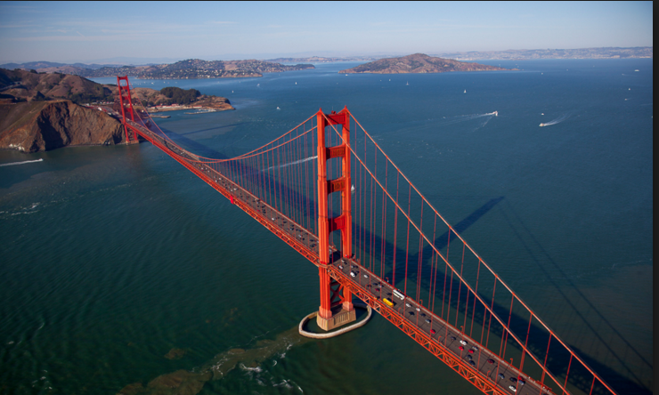

3 Night Stay in Beautiful TAhoe West shore home
ITEM #4
VALUE: $1,500
This beautiful private home sits high on Lake Tahoe’s West Shore, just upslope from Sunnyside. The house is a short walk to delightful Paige Meadows with trails for walking and biking in the summer, or snow-shoeing and cross-country skiing in winter (four-wheel drive is necessary in winter). It is a short drive from the house to Homewood and Alpine Meadows skiing, Tahoe City, and numerous beaches.
Come stay for three nights in any season. Enjoy the natural beauty and serenity of Lake Tahoe. This fully furnished, recently remodeled home includes:
• 5 bedrooms and 3 ½ baths sleeps up to 10 people with 3 fireplaces
• Separate level master suite that includes fireplace, an oversize glass shower and Jacuzzi tub
• Satellite TV and wireless internet
• 3 levels of living space, decks on each level. a great room and kitchen/dining area upstairs with views of forest and the lake, and a large rustic den with wet bar downstairs
Donated by: Mathews-Gilkerson Family
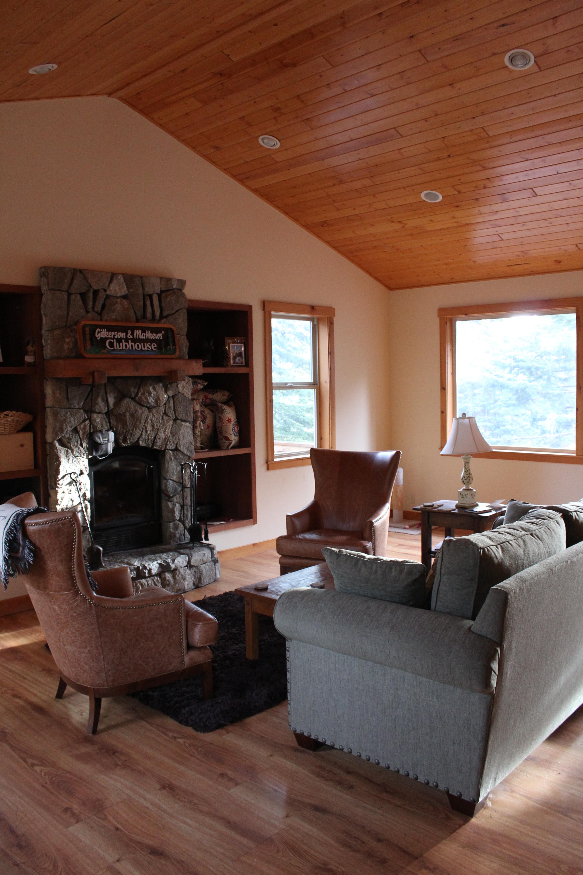
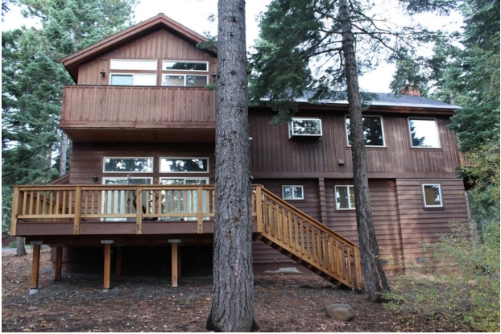
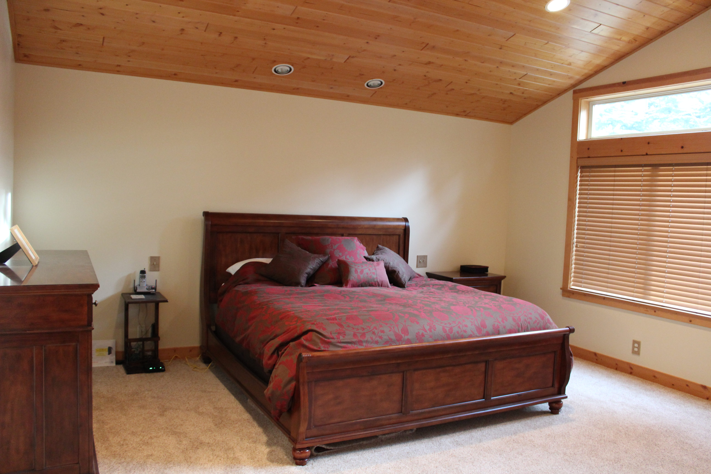

MSA BAND PLAYS AT YOUR PRIVATE PARTY
Item#
VALUE: PRICELESS

Is a party in your future? Elevate your graduation, birthday, holiday, or any party with your own private indie rock band. Marin School of the Art’s talented Rock Band members: Sal Meblin, Hazle Thunes, Adam Brodsky, and Patrick Kelly will come play a 30 minute set at your home or office party and turn it into the talk of the town.

Donated by: Sal Meblin, Hazle Thunes, Adam Brodsky, and Patrick Kelly

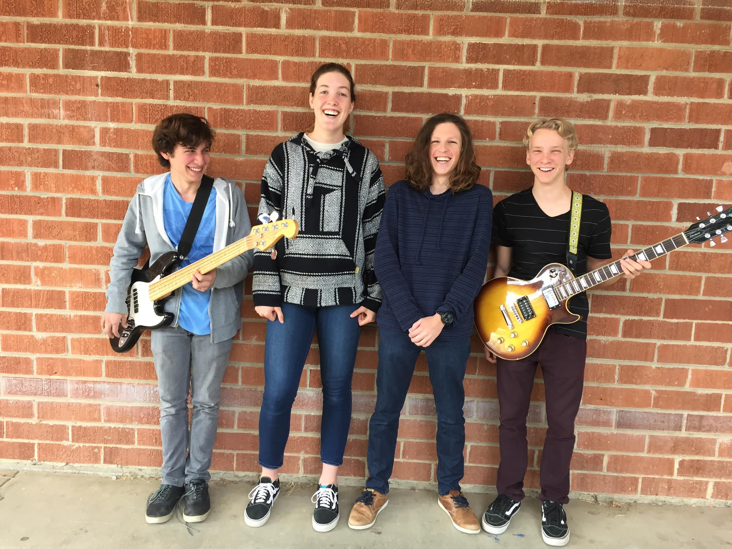

HOMEMADE TIRAMISU & CHAMPAGNE
Item#
Value: priceless
Treat your table to a special homemade tiramisu for dessert and two bottles of chilled Veuve Clicquot Champagne. Chef Debbie DeGeorge lovingly prepared this amazing dessert that we are serving to only one table tonight. The lucky winners will get the tiramisu and chilled champagne delivered right to your table for dessert this evening.

Donated by: Debbie DeGeorge and Susan Mathews

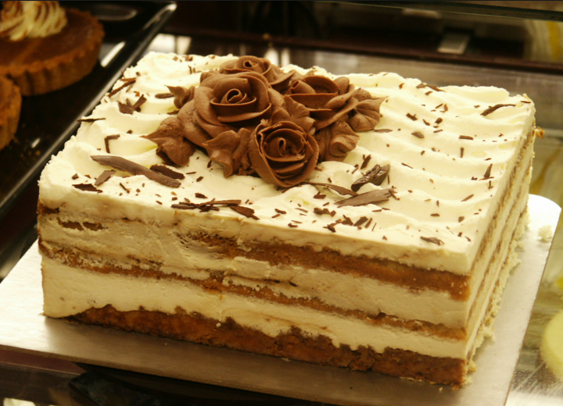
Vacation IN MEXICO With AIRFARE
Item#
Value: $2,900
Spend a week in San Miguel de Allende in a newly remodeled casa! Choose your date: December 21-27, 2016 or April–December 2017. Vacation includes round trip airfare to Mexico for two (up to $2,000).

This beautiful two-story casa has 3 bedrooms, 3.5 baths, an open roof garage, outside patio on the ground floor and a rooftop terrace. Cook your own meals in the chef’s kitchen or be served in style at any on of the many fine restaurants nearby.

The house is located in a vibrant, upbeat neighborhood with excellent restaurants and shopping, gourmet food shops, yoga, Spanish school, the Instituto and the San Juan de Dios Market.

Flight details: Two round trip plane tickets up to $1,000 each for travel from US 50 to Mexico, Caribbean, or Canada; or two round trip plane tickets up to $500 each off any airline ticket. No blackout dates. Valid on most airlines. Winner can pay the difference if tickets are greater than $1,000 to Mexico, Caribbean, or Canada, or $500 on the other tickets.

Dates for the Mexico house need to be mutually agreed upon by the donor and the winner.

Donated by: Pam Juckas and Kirsten and Clark Omholt

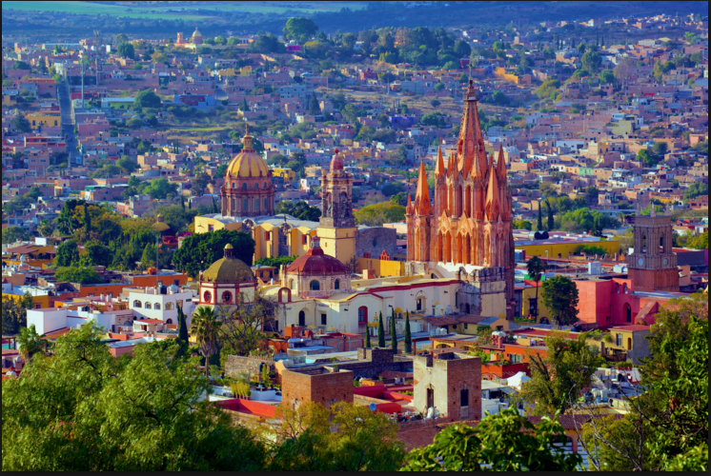

ROCK THE NIGHT AWAY
PLAY OR SING WITH THE HAMILTONES
Item#
VALUE: PRICELESS

Have you always wanted to be a star? Now's your chance – take the stage tonight with the Hamiltones and rock this Gala inside out!

Join the band as lead singer (shiny disco shirt optional) or pick up any instrument. Consult with the band and suggest your favorite song or pick one from their extensive play list. Hamiltone crowd favorites include:

Sweet Home Alabama - Lynyrd Skynyrd
Sweet Caroline - Neil Diamond
Brick House - Commodores
867-5309 - Tommy Tutone
Rock This Town - Stray Cats
Jumping Jack Flash - Rolling Stones
Keep Your Hands to Yourself - Georgia Satellite
Taking Care of Business – BTO

Donated by: The Hamiltones

BEST SEATS IN THE HOUSE
GRADUATION Press BOX SEATing for 8
With 2 VIP Parking Spaces
Item#
VALUE: PRICELESS

Arrive to Novato High graduation virtually stress-free knowing you have the best parking and seats in the house already reserved. You won’t have to arrive hours early to jockey for parking spaces or seats in the stands. Avoid sitting around in the blazing sun waiting for graduation to start.

Step into your shaded and decorated press box seating for 8 complete with cold “mocktails,” fruit and appetizers.

Photos are a snap as you are above it all with no one’s head marring your perfect shot of your graduate.

Donated by: Novato High School and the Mathews-Gilkerson Family

The SUITE LIfe
NIGHT OUT IN SAN FRANCISCO
Item#6
Value: $1,025
San Francisco's upscale Clift Hotel invites you to "defy convention" with a one night stay in the truly special deluxe suite, with breakfast for two and overnight parking included and a bottle of wine.

A haven of luxury, the suite offers high ceilings, a formal dining room and oversized bathroom with dressing area. Luxuriate in fine linens, MALIN+GOETZ bath amenities and a state-of-the-art entertainment system. Beautifully crafted and detailed furniture designed by Philippe Starck feature English sycamore, silk, leather, velvet, chrome and Venetian Murano glass.
With your $150 gift certificate at Gaspar Brasserie, you will enjoy a delicious French dinner set in an atmosphere reminiscent of a Parisian brasserie with modern mid-20th century flair. Gaspar cuisine, helmed by Executive Chef Chris Jones, showcases a menu of approachable brasserie fare comprised of classic French dishes, with the local Northern California landscape woven throughout.
Donated by: Clift Hotel, Gaspar’s Brasserie, and the Gruener Family

